
NORTHERN EDUCATION DIVISION MOCK EXAMINATION
2026 MALAWI SCHOOL CERTIFICATE OF EDUCATION EXAMINATIION

BIOLOGY II
(100 marks)
Monday, 30th March 2026. Subject Number: M022/II
Time allowed: 2 hour Session

Instructions
- This paper contains 6 pages please check.
- Answer all questions
- In the table provided on this page, tick against the question number answered
- Write your full name and school on each and every page
- Hand in your paper to the invigilator when time is called to stop.

Question Number | Tick if answered | Do not write in these columns
1
2
3
4

SECTION A (20 MARKS)
1. Describe an experiment that would be used to estimate the density of grasshoppers in a school garden. Your answer must include materials, procedure, expected results and conclusion in an essay form.
_____________________________________________________________
______________________________________________________________ ______________________________________________________________
______________________________________________________________ ______________________________________________________________ ______________________________________________________________
______________________________________________________________ ______________________________________________________________ ______________________________________________________________ ______________________________________________________________
______________________________________________________________ ______________________________________________________________ ______________________________________________________________ ______________________________________________________________ ______________________________________________________________
______________________________________________________________ ______________________________________________________________ ______________________________________________________________ ______________________________________________________________ ______________________________________________________________ ______________________________________________________________
___________________________________________________________________________________________________________ 10 Marks
2. Describe an experiment that would be used to find out the effect of unequal distribution of light on a growing shoot. In your answer include method (procedure), expected results and conclusion.

______________________________________________________________ ______________________________________________________________ ______________________________________________________________ ______________________________________________________________ ______________________________________________________________
______________________________________________________________ ______________________________________________________________
____________________________________________________________________________________________________________________________________________________________________________________________________________________________________________________________________________________________________________________________________________________________________________________________________________________________________________________________________________________________________________________________________________________________________________________________________________________________________________________________________________________________________________________________________________________________________________________________________________________________________________________________________________________________________________________ (10 marks)

SECTION B (20 MARKS)
3. You are provided with two leaves labelled A and B. Use them to answer the questions that follow:
a. What type of leaves does leaf A and B belong:-
A: ___________________ B: _____________________
(2 marks)

b.

i.

Draw leaf A and label any 3 parts.

(4 marks)
- Measure the length of the specimen A and record its value in mm.
(1 mark)

- Calculate magnification of the leaf drawn.

(3
marks
)

4. Figure 1 is a diagram of 5 animals
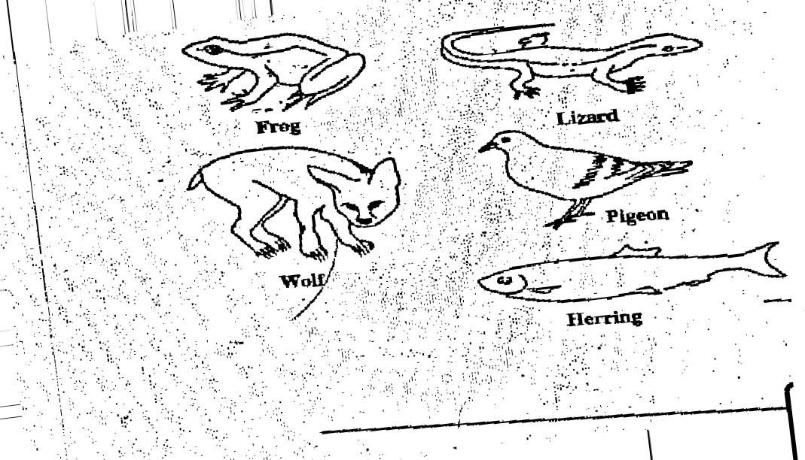

Construct dichotomous key

8 Marks

b. Explain one adaptation of pigeon to locomotion

______________________________________________________________________________________________________________________ 2 Marks

END OF QUESTION PAPER

